

1. MAKING E-PAYMENT

If you wish to pay by eNETS Debit:

- You will need to have an internet banking account User ID and PIN from DBS/POSBank, UOB, OCBC or Standard Chartered Singapore.

- For more information on eNETS Debit and how to apply for an internet banking User ID and PIN, please visit : https://www.nets.com.sg/faqs/faq-enets-personal/

2. HOW TO MAKE E-PAYMENT ?

To make a e-payment:

- Click on ‘here’ to initiate eNETS payment request.

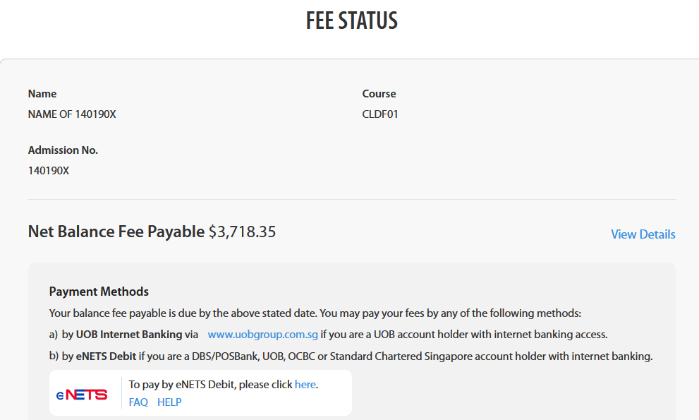
- Check admission no., course code and payment amount.
Proceed with reCAPTCHA verification and click on ‘Continue to Payment’.

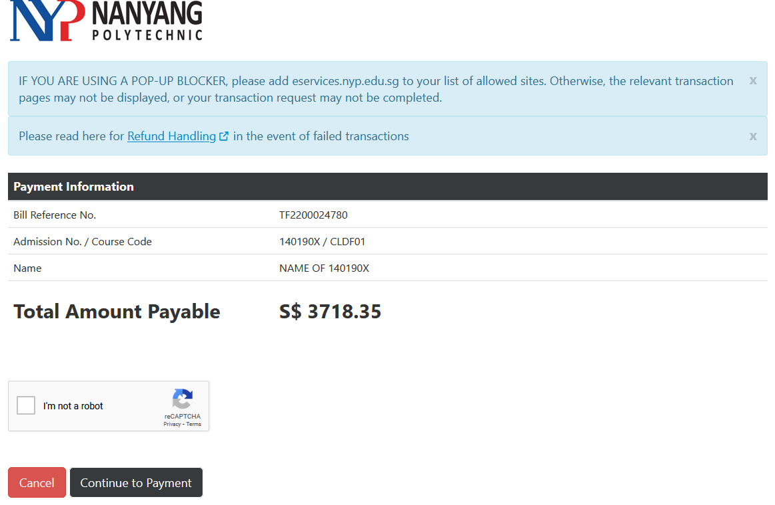

- Select the bank that you will be using for payment.
You will be brought to bank’s login page. Follow the instruction on the bank page and proceed to make payment.
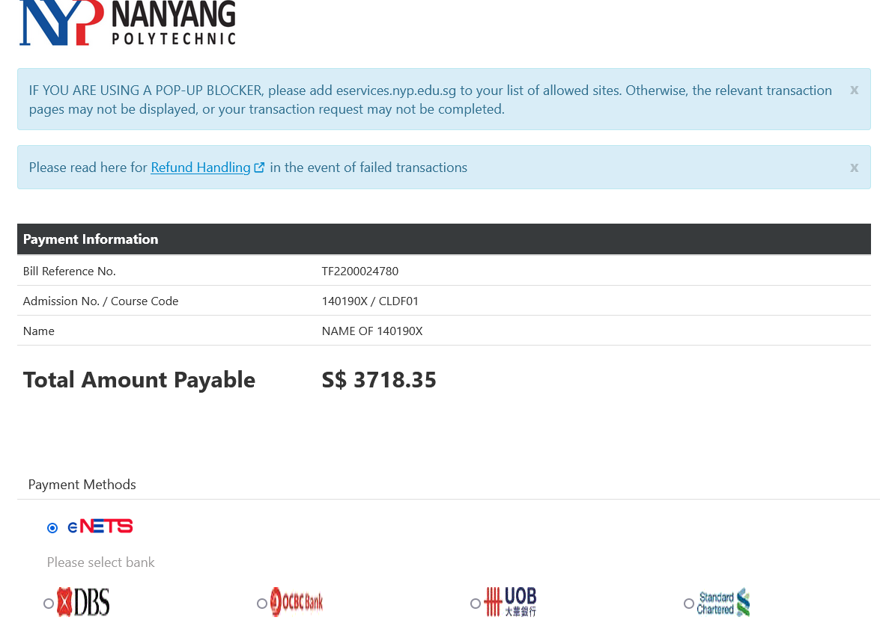

- Once transaction is successful, you will be redirected back to NYP payment gateway receipt page.
